|  |
| --- |
| Brock Point Residential Association |
|  |

October 3, 2023

Dear Brock Point Neighbors,

Happy Fall! This time of year is always so beautiful around Brock Point as fall flowers start to bloom, leaves change colors and front porches are made to look like festive magazine covers. The Board is reaching out to clarify Mailbox Standards, please see the Mailbox Standards Addendum following this letter.

Per the Architectural Standards, found on our website ([www.brockpointliving.com](http://www.brockpointliving.com)), mailboxes are to be uniform. This includes the material (brass), font, style, dimensions, color, etc. of the numbers on the top address plaque, a secure newspaper holder, and matte black finish on the entire mailbox.

**Architectural Standards for Brock Point Residential Subdivision, v3 (amendment), January 19, 2023**

**Page 4**

**6. Mailboxes**. Each Lot shall have a mailbox which shall be of a design as shall be prescribed and approved in advance by the ARC. All such mailboxes shall match throughout the Subdivision. In the event there has been a discontinuation of the product, a new complimentary design will be selected by the Board and ARC and each Homeowner shall replace the discontinued design with the newly selected design as replacement is needed on each Lot. Each Owner will be required to keep such mailboxes in good working order and repair, including the replacement numbers when faded. No stickers, covers, hanging plants or other decorative items (except at holidays) shall be allowed on the mailbox or post. Names are not allowed on the mailbox or post. Street numbers shall be of the approved style and color and NOT painted/applied to the curbs

Please remember to submit a request for ARC approval for any changes to the exterior of your property. If you have any questions, feel free to contact any of your volunteer neighbors serving on the ARC or Board. ARC Request can be submitted on our website [www.brockpointliving.com](http://www.brockpointliving.com).

Sincerely,

Brock Point Residential Association Board

|  |
| --- |
| Mailbox Guidelines for Repair and Maintenance |
|  |

Cleaning options:

* Numbers: Brasso is recommended cleaning product, then application of polyurethane to protect from discoloring. Liquid Bar Keepers Friend also works.
* Mailbox: Black FLAT paint for the mailbox assembly.

Vendors:

There are several options and vendors to choose from, below are a few, but not all.

* Alabama Mailbox [www.AlabamaMailbox.com](http://www.AlabamaMailbox.com)  phone #205-594-4413
  + vendor used by Signature Homes in original installation.
* Mailbox Store USA [www.mailboxstoreusa.com](http://www.mailboxstoreusa.com) phone #770-535-0036
* Mailbox Project [www.mailboxproject.com](http://www.mailboxproject.com) phone #770-535-0036

Replacement options: pictures below are from mailboxstoreusa.com and prices as of 9/2023

* **Mailbox System (Mailbox 08 (311k BLK))**

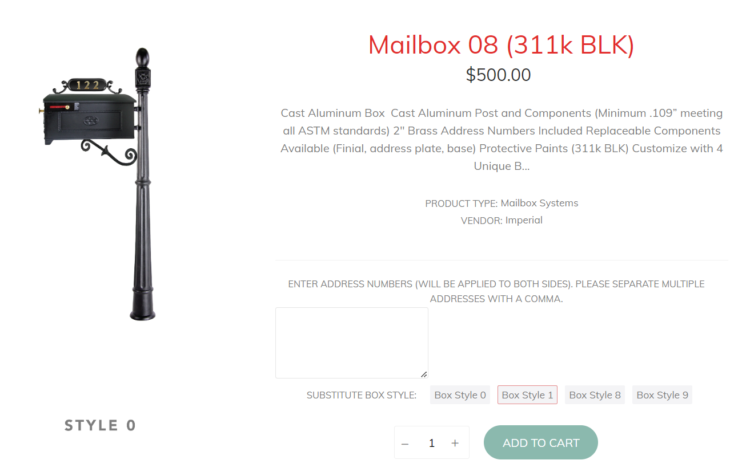

* **Mailbox (Style 1K)**

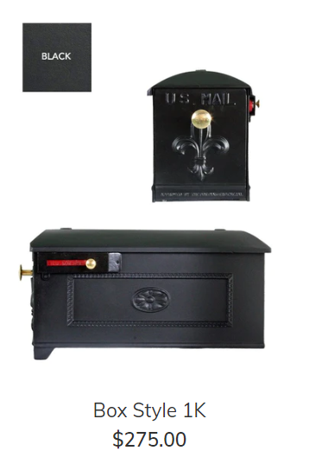

* **Newspaper holder**

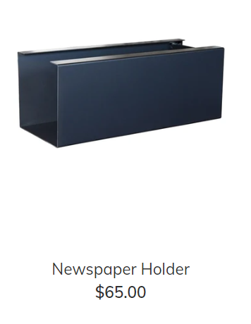

* **Bracket: S-Scroll (Vendor: Imperial)**

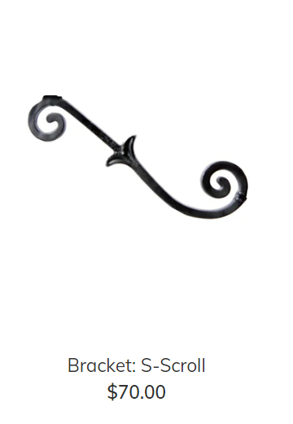

* **Address Plate (Plate 1)**

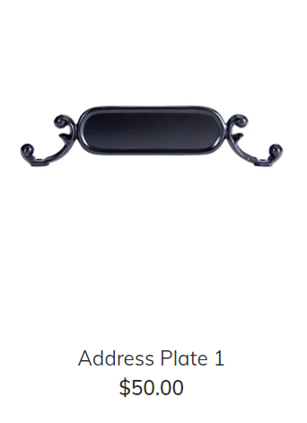

* **Brass Numbers (2” Address Numbers (Brass, Self-Adhesive, VENDOR: Imperial)**

[https://mailboxstoreusa.com](https://mailboxstoreusa.com/collections/parts/products/address-numbers-2-brass)

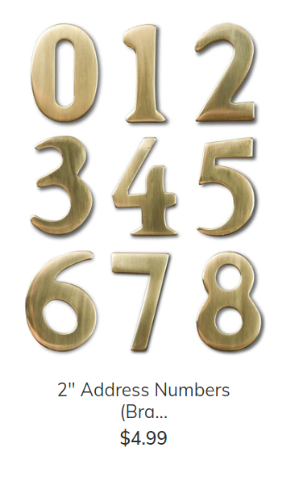

* **Brass Knob (Large – Handle Pull)**

* **Flag Assembly (Large)**

